JComboBox.

The objective of this practice is to obtain the following program:
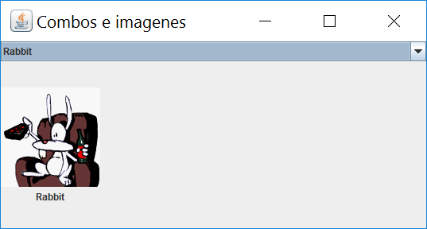
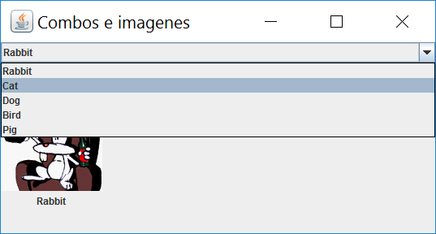
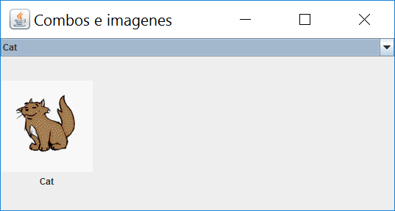
We create a project called practiceCombo and once the project is created we will add a java class called frame to design the window:
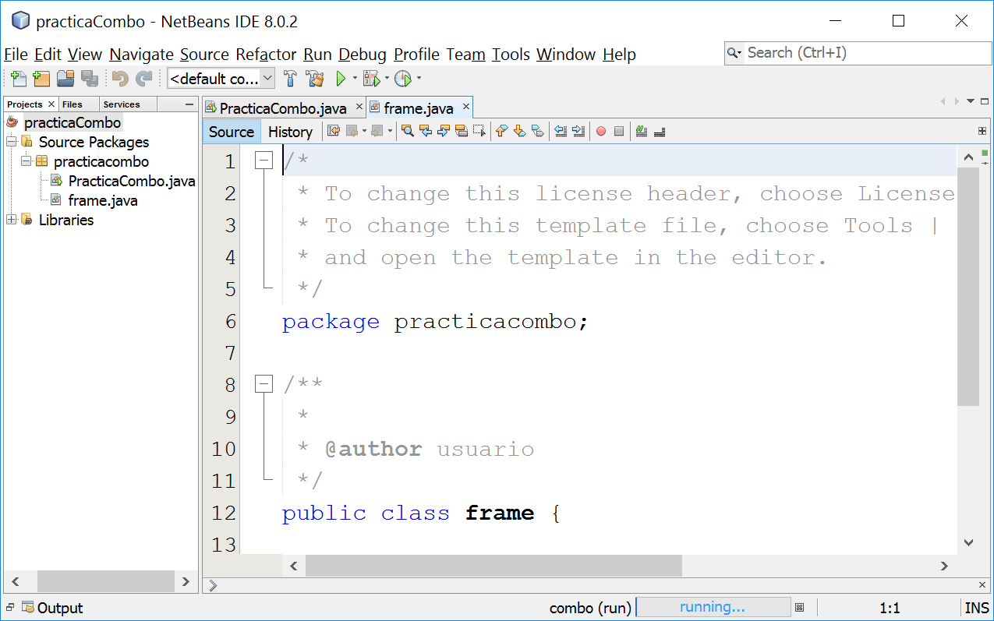

As always in the frame we will create the minimum structure of a window:

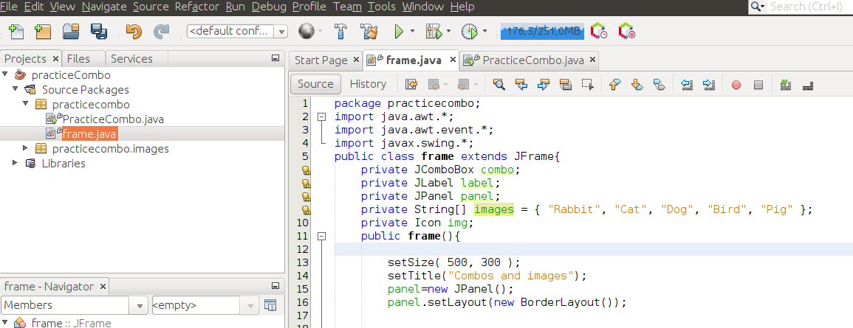
I have also defined the following variables: combo, label (to show the images), images (a string vector to give the combo content) and img (which will be used to search for an image from the disk and place it on the label).
Before continuing we must create a directory where the images to use reside (included in images.rar that accompanies this document). In principle, the images can be in any disk site, to access them you must put the path and name of the image, for convenience we will copy them unzipped in the project directory where the sources reside:
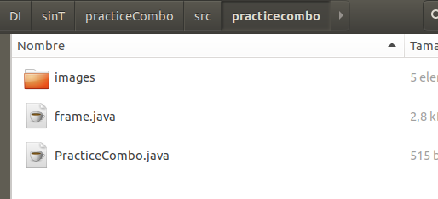

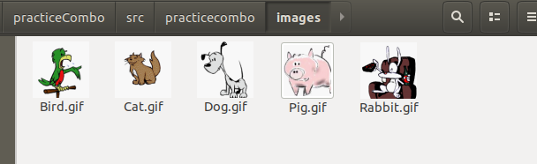

If it doesn’t work we can check the path

System.out.println(System.getProperty("java.class.path"));

And place it there

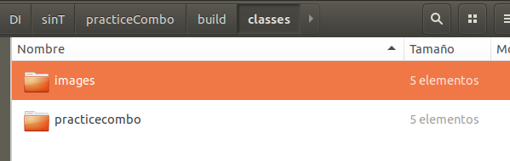

Now that we have located the sources, we are going to continue with the project. First we will instantiate the combo and put it in the panel:
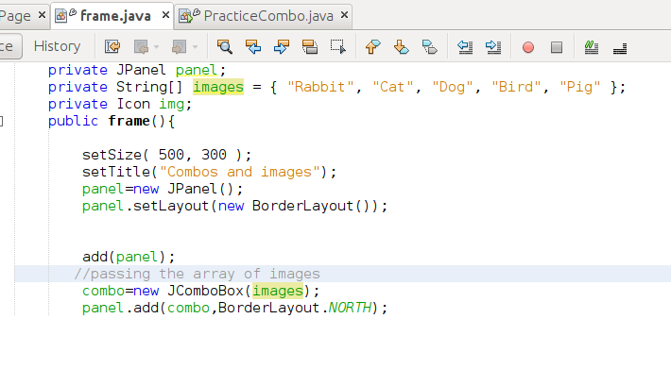

To test what we have done we are going to instantiate a frame in the PracticaCombo.java class:
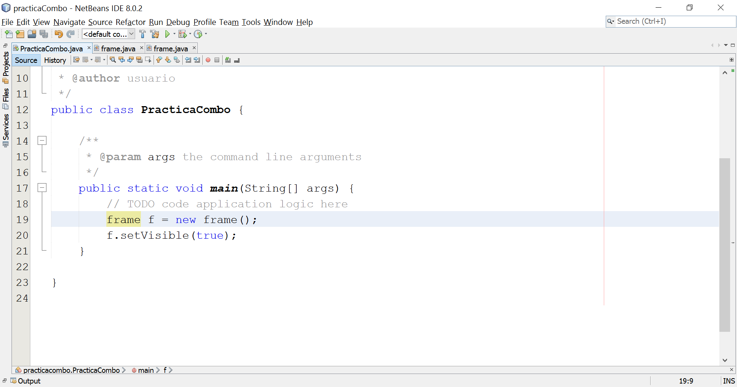
And we execute:
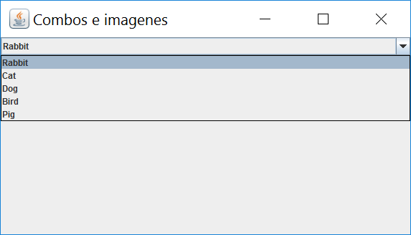
We are now going to create a label with an image, using an ItemIcon object:

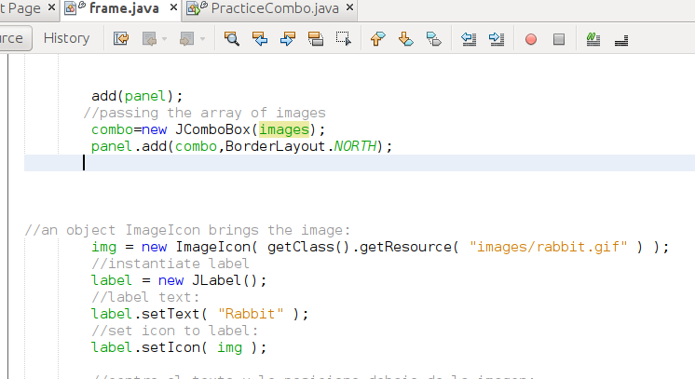

If we execute:
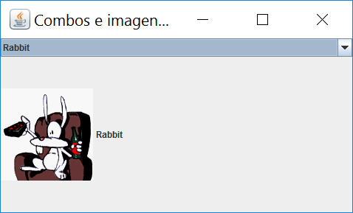
We see that the text of the label appears next to the image, if I want it to appear below the image and centered I add:

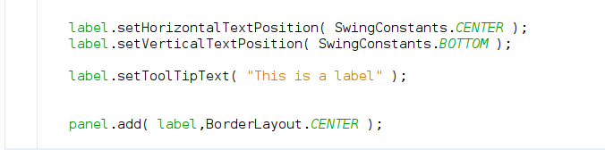

We now have if we execute:
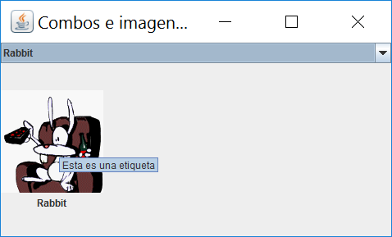
We already have the basics of the window. We are now going to add an event listener to the combo, to change the image depending on whether one text or another is selected in the combo:

Combos must implement the ItemListener interface and override the itemStateChangen method. This event occurs when the user selects the different elements of a combo.
Now I add this listener to the combo:

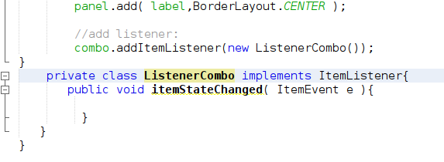

But this event does nothing, let's put the necessary code. We will use the combo.getSelectedIndex () method to index on the image vector and load the image and appropriate text in the label:

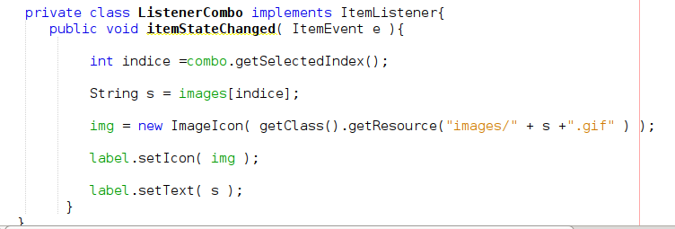

We already have our program ready !!!

